**Transformation 2**

**Design Pane**

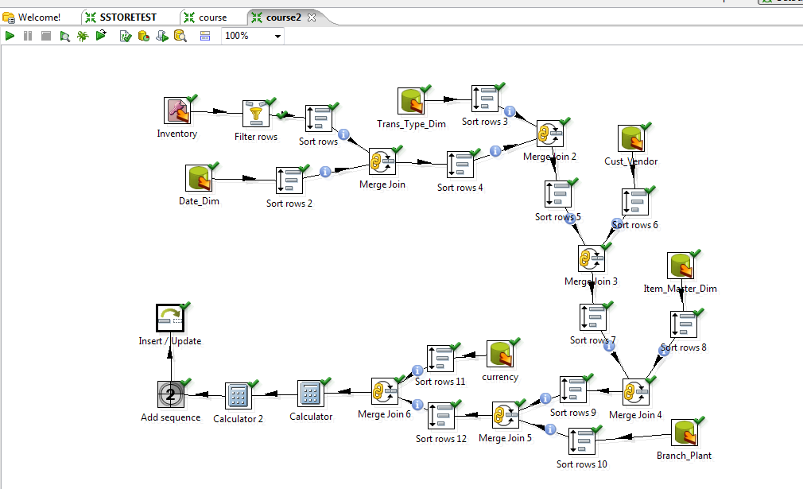

**No of rows inserted**

